USER’S

MANUAL

181 North Place Residence

Table of Contents

1.0 GENERAL INFORMATION 2

1.1 System Overview 2

1.2 Organization of the Manual 2

2.0 SYSTEM SUMMARY 4

2.1 System Configuration 4

2.2 User Access Levels 4

2.3 Contingencies 4

3.0 GETTING STARTED 6

3.1. Install WampServer 6

3.2. Import Database using WampServer 2.5 6

3.3. Install JDK 9

3.4. Install U.are.U Driver 12

3.5. Install Server 13

3.6. Install Monitoring System 13

3.7. Install Lobby System 14

3.8. Install Backup and Recovery 15

4.0 USING THE SYSTEM 17

4.1 Launching the System 17

4.1.1 Launching the Server 17

4.1.2 Launching the Monitoring System 17

4.1.3 Launching the Lobby System 17

4.1.4 Launching the Backup and Recovery 17

4.2 Admin 18

4.2.1 Login 18

4.2.2 Add Admin 18

4.2.3 Edit Profile 18

4.2.4 Change Password 18

4.2.5 Logout 19

4.2.6 iLogBook 19

4.2.7 Admin Privileges 19

4.2.8 Notification 21

4.3 Lobby 22

4.3.1 Time-in and Time-out of resident 22

4.3.2 Visitors Log-in 23

4.3.3 Visitors Log-out 24

4.3.4 Resident Search 25

4.3.5 Permit to use the Building Premises 25

4.4 Resident 25

4.4.1 Reservation 25

4.4.2 Registration 26

4.4.3 Activation 28

4.4.4 Edit Resident Profile 28

4.4.5 Billing 30

4.4.6 Leave 32

4.5 Transient 32

4.6 Back-up and Recovery 33

4.7 Report Generation 35

4.7.1 Archives 35

1.0 GENERAL INFORMATION

# 1.0 GENERAL INFORMATION

General Information section give details in general terms the system and the purpose for which it is intended.

## 1.1 System Overview

181 North Place Residences Monitoring System is an automated monitoring system that uses a biometric device for the time logs, have a database for keeping records and allow the sending of important notifications through SMS text messaging and e-mail that contains of the violations like curfew and not complying with the house rules, special announcements, new roommates, visitors, balances and payments due.

## 1.2 Organization of the Manual

The user’s manual consists of five parts: General Information, System Summary, Getting Started, Using the System and Reporting.

General Information section give details in general terms the system and the purpose for which it is intended.

System Summary section presents a general overview of the system. The summary delineates the uses of the system, system’s configuration, user access levels and system’s behaviour in case of any contingencies.

Getting Started section describe how to install the system.

Using The System section provides a detailed description of system functions.

2.0 SYSTEM SUMMARY

# 2.0 SYSTEM SUMMARY

System Summary section presents a general overview of the system. The summary delineates the uses of the system, system’s configuration, user access levels and system’s behaviour in case of any contingencies.

## 2.1 System Configuration

181 North Place Residences: Automated Monitoring System is a stand-alone system. It is compatible with Windows 7 or higher versions of operating system. The application requires internet connection to enable sending of text messages and e-mail to the residents, resident’s parent or guardian. Data saved in database can be seen in the MySQL Workbench. After installing on the computer, 181 North Place Residences: Automated Monitoring System can be used immediately*.*

## 2.2 User Access Levels

The management is the only one who can use the system while, the resident can only use the biometric device.

## 2.3 Contingencies

In case of power outage data are not saved in internal memory of the operating device and there is no Internet connection available data cannot be saved in internal memory of the operating device, instead for the meantime use an Excel for the time-in and time-out of each resident as well as the visitors and record all the operations in the dormitory using forms. And when the power is already working, Back-up and Recovery is available for the management to input or upload the records. In case of data corruption, Back-up and Recovery is available to recover the previously backed-up records.

3.0 GETTING STARTED

# 3.0 GETTING STARTED

Getting Started section describe how to install the system.

## 

## 3.1. Install WampServer

3.1.1. Download and install WampServer 32bit/64bit Version 2.5 or above from: <http://www.wampserver.com/en/>

## 

## 3.2. Import Database using WampServer 2.5

3.2.1. Import Database:

3.2.1.1. Go to your browser and then type into the address bar the following : <http://localhost/phpmyadmin/index.php>

3.2.1.2. Press enter.

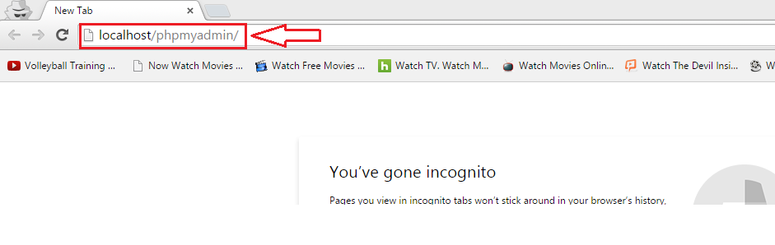

3.2.1.3. Press *Import.* 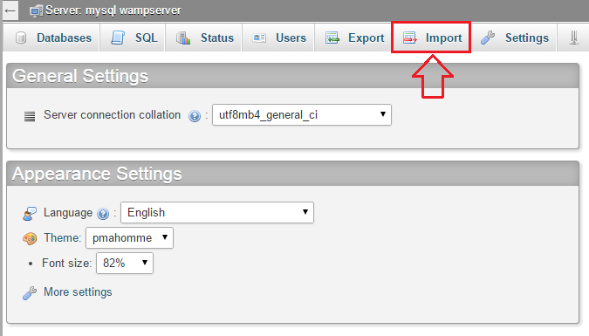

3.2.1.4. Press *Choose File.*

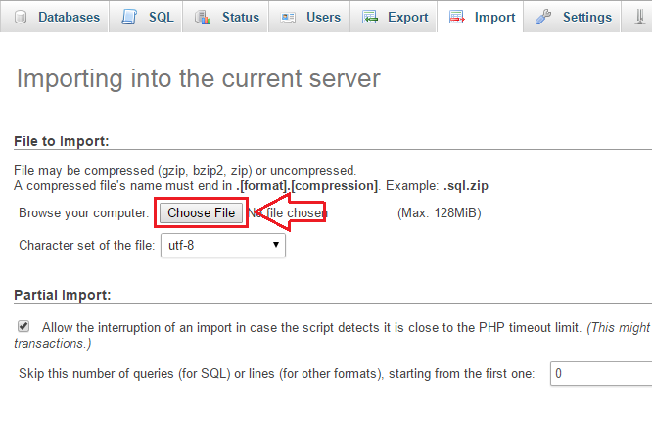

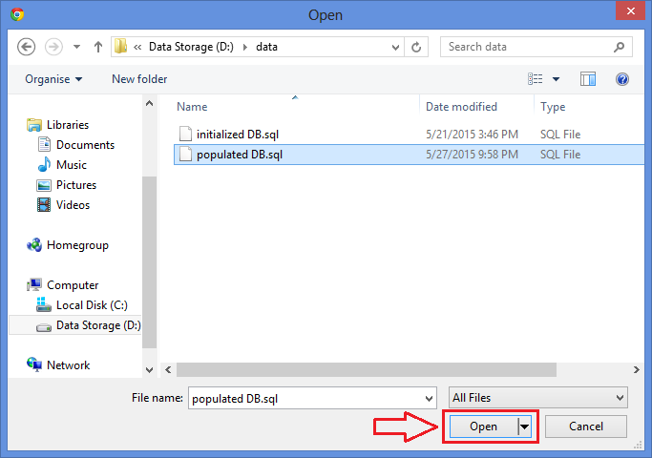3.2.1.5.Choose the sql file (initialized DB.sql or populated DB.sql) provided: ..\data\initialized DB.sql or ..\data\populated DB.sql

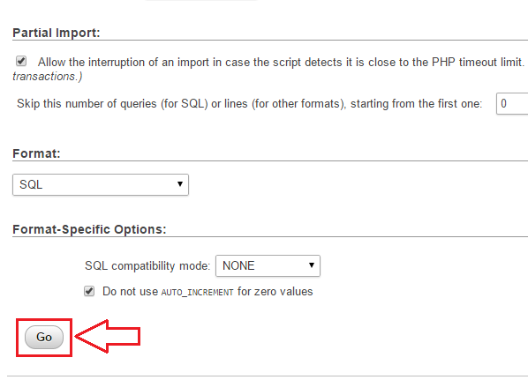3.2.1.6. Scroll down and Press *Go.*

3.2.1.7. Wait until it is finished. Then a message will prompt:

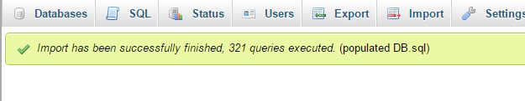

## 

## 3.3. Install JDK

3.3.1. Download Java SE Development Kit 8(or above) Windows x64 and

Windows x32 from: <http://www.oracle.com/technetwork/java/javase/downloads/jdk8-downloads-2133151.html>

3.3.2. Install Java 8 SDK 64 bit

3.3.2.1. Add JAVA_HOME in System Variables

3.3.2.1.1. Go to Environment Variables: Computer > Properties > Advanced System Setting > Environment Variables

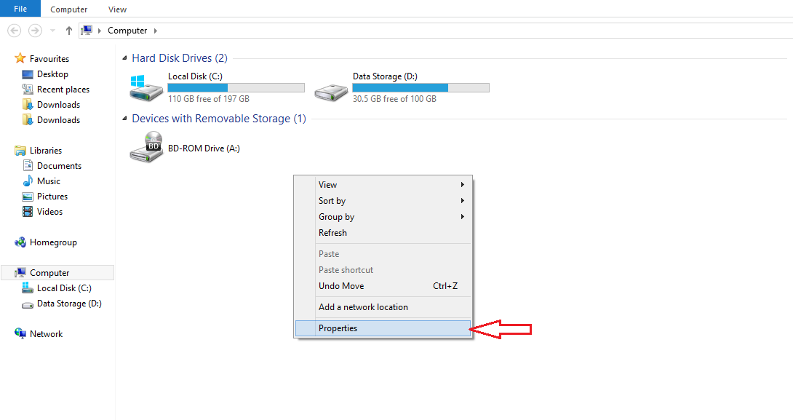

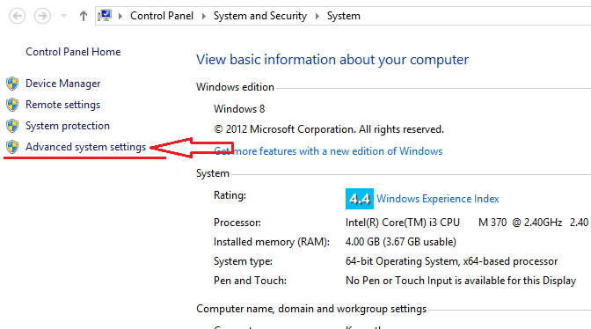

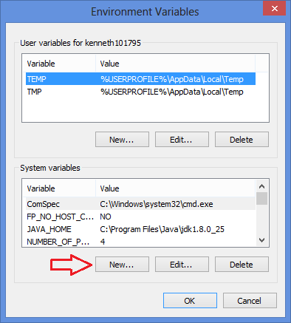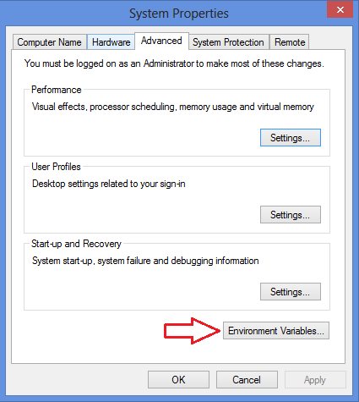

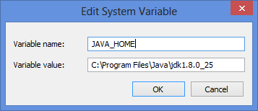

3.3.2.1.2. Then add JAVA_HOME with the path of the existing JDK

(eg. C:\Program Files\Java\jdk1.8.0_25)

## 

## 3.4. Install U.are.U Driver

3.4.1. Install the Digital Persona U.ARE.U driver (SETUP.exe) provided

..\res\UareU\SETUP.exe

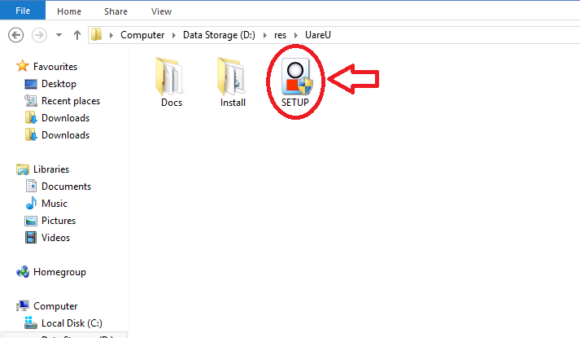

## 3.5. Install Server

3.5.1. Install the server system (181NPRServerSetup.exe) provided

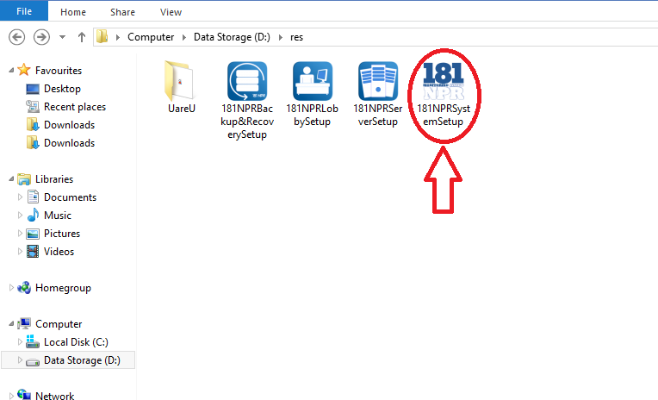..\res\181NPRServerSetup.ex

*Note:*

Open command prompt to check ipv4 address by typing “ipconfig”. The ipv4 address will be used to connect the Lobby Unit.

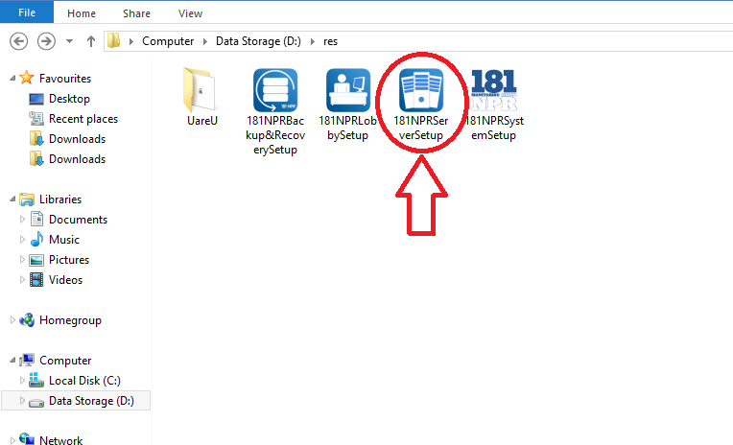

## 3.6. Install Monitoring System

3.6.1. Install the main system (181NPRSystemSetup.exe) provided

..\res\181NPRSystemSetup.exe

*Note:*

Open command prompt to check ipv4 address by typing “ipconfig”. The ipv4 address will be used to connect the Lobby Unit.

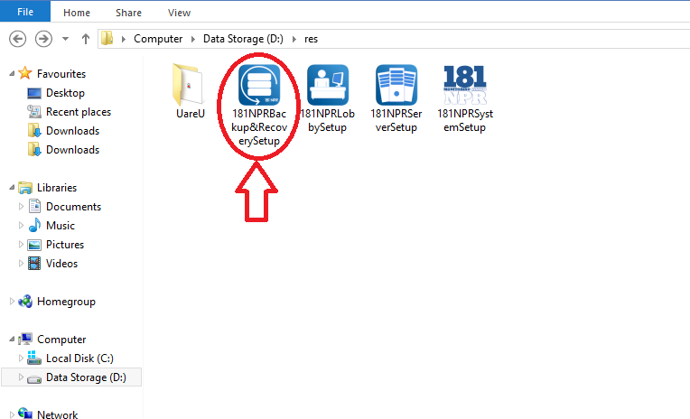

## 3.7. Install Lobby System

3.7.1. Install the lobby system (181NPRLobbySetup.exe) provided

..\res\181NPRLobbySetup.exe

*Note:*

Make sure the lobby unit, monitoring system and the server are in one (1) network.

If the lobby unit is not connected to the server, type the ipv4 address of the server in the prompt message asking for ipv4 address.

## 3.8. Install Backup and Recovery

3.8.1. Install the backup and recovery system (181NPRBackup&RecoverySetup.exe) provided

..\res\181NPRBackup&RecoverySetup.exe

4.0 USING THE SYSTEM

# 4.0 USING THE SYSTEM

Using The System section provides a detailed description of system functions.

## 4.1 Launching the System

### 4.1.1 Launching the Server

4.1.1.1 Click the 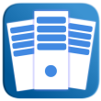 icon to access the server.

4.1.1.2. To start the server click .

4.1.1.3. To restart the server click .

4.1.1.4. To stop the server click .

*\*\*Note: You cannot access the system without starting the server.*

### 4.1.2 Launching the Monitoring System

4.1.2.1. Click the  icon to access the monitoring system.

4.1.2.2. To start the system, a log-in interface will prompt.

### 4.1.3 Launching the Lobby System

4.1.3.1. Click the 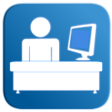 icon to access the lobby.

### 4.1.4 Launching the Backup and Recovery

4.1.4.1. Click the 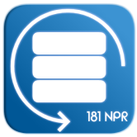 icon to access the back-up and recovery of the system.

## 4.2 Admin

### 4.2.1 Login

1. To Login type the credentials of the admin, the username and the password.

2. Click .

### 4.2.2 Add Admin

***First Option:***

1. Click the admin picture, located at the upper left of the interface.

2. Click List of Admins.

3. Click Add Administration, located at the lower left of the interface.

4. After filling up the information, click .

***Second Option:***

1. Click .

2. Click .

3. Click 

4. After filling up the information, click .

### 4.2.3 Edit Profile

1. Click the admin picture, located at the upper left of the interface.

2. Click Edit Profile.

3. After editing, click .

### 4.2.4 Change Password

1. Click the admin picture, located at the upper left of the interface.

2. Click Change Password.

3. Type the current password, the new password and the confirmation of the new password.

4. Click .

### 4.2.5 Logout

1. Click the Admin picture, located at the upper left of the interface.

2. Click Logout.

### 4.2.6 iLogBook

1. Click .

2. Click .

### 4.2.7 Admin Privileges

#### 4.2.7.1 Accounts

1. Click .

2. Click 

3. Click .

4. Input the new Default Accounts.

4.1 The  beside the *Biometrics* is used when the biometric is available (Yes) and unavailable (No).

5. To adjust the curfew hour:

5.1 Click .

5.2 Adjust the hour, minute, second, and period.

6. Click  .

7. Click  to go back to the Admin Privileges menu.

#### 4.2.7.2 Manage Furniture

1. Click .

2. Click 

3. Click .

4. Check the furniture to be edited.

5. Click .

5.1 Edit the data to be edited.

5.2 Click .

6. Click , to add a new furniture.

6.1 Input the information of the furniture.

6.2 Click .

7. Click  to go back to the Admin Privileges menu.

#### 4.2.7.3 Room Rate

1. Click .

2. Click 

3. Click .

4. Select the room type .

5. Input the new room rate.

6. Click .

7. Click  to go back to the Admin Privileges menu.

#### 4.2.7.4 Shuttle Rate

1. Click .

2. Click 

3. Click .

4. Input the new Shuttle rate for Daily or Monthly.

5. Click .

6. Click  to go back to the Admin Privileges menu.

#### 4.2.7.4 Transient Rate

1. Click .

2. Click 

3.Click

4. To change the Family rate and Regular rate of the:

4.1 Current Transient Rate

4.1.1 Input the new Family Rate and Regular Rate

4.2 Current Extra Beddings Rate

4.2.1 Input the new Family Rate and Regular Rate

4.3 Current Private Suite Rate

4.3.1 Input the new Family Rate and Regular Rate

5. Click Click .

6. Click  to go back to the Admin Privileges menu.

### 4.2.8 Notification

1. Click .

2. Click .

3. Click *Residents:*

3.1 Select a resident.

3.2 Click ,

3.2.1 Select the template in the drop down list 

3.2.2 Click .

3.3 Click ,

3.3.1 Select the template in the drop down list 

3.3.2 Click .

4. Click *Transients and Reservations:*

4.1 Select a transient or reserver

4.2 Click ,

4.2.1 Select the template in the drop down list 

4.2.2 Click .

4.3 Click ,

4.3.1 Select the template in the drop down list 

4.3.2 Click .

5. Click  to go back to the main menu.

#### 4.2.8.1 Sent Box

1. Click *SENT BOX,* at the upper left corner of the window. It will display the Time, Name of the receiver, the communication used (email or text), the type of the message, and the table where it came from.

2. To view the Message Details, double click the row.

## 4.3 Lobby

### 4.3.1 Time-in and Time-out of resident

1. By default, the Resident Time In/Out interface will automatically appear.

2. For the resident to time in/out, click 

3. Then, place the registered fingerprint of the resident in the fingerprint scanner.

3.1 If the fingerprint is recognized, the resident's name and status (logged in/out), will appear.

3.2 If the fingerprint is not recognized within three consecutive tries, the resident will type his/her ID number, then click .

3.2.1. If the the ID number is recognized, a Successful dialog box will appear, click .

3.2.2 If ID number is not recognized, Unsuccessful dialog box will appear, click  to re-enter the resident ID number.

4. Click the  to go back to the main menu of the Lobby Interface.

#### 4.3.1.1 Register Fingerprint

1. Click the .

2. Input the Admin Credentials.

3. Select the resident to be registered.

4. Right Click the Finger 1.

5. Click *Register.*

6. Click  .

7. Place the finger to be registered.

8. Click the *Validate 1,* then place the finger that was register.

*Note: Fingerprint Match will be shown if the finger print are matched, Fingerprint Unmatched will be show if fingerprint are unmatched.*

9. Click the *Validate 2*, then place the finger that was registered.

*Note: Fingerprint Match will be shown if the finger print are matched, Fingerprint Unmatched will be show if fingerprint are unmatched.*

10. Repeat step 6 to 9 for the Fingerprint 2.

11. Click .

### 4.3.2 Visitors Log-in

1. By default, the Resident Time In/Out interface will automatically appear.

2. Click the .

3. Click 

4. Fill up the information.

5. Select the reason for visiting.

6. Select the resident name to whom he will visit.

*\* *NOTE: But if the reason is for inquiring no need to select the resident name.*

7. If the visitor would like to inform the resident about his visit click the *.*

8. Click .

9. Click the  to go back to the main menu of the Lobby Interface.

### 4.3.3 Visitors Log-out

1. By default, the Resident Time In/Out interface will automatically appear.

2. Click the .

3. Click 

4. Click the , located at the upper left.

5. Select the visitor name or the name of the resident in the *'Group Visit'* that will logout. You can also search the name in the search field provided.

6. Click .

7. Click the  to go back to the main menu of the Lobby Interface.

### 4.3.4 Resident Search

1. To search for a resident, click the  .

2. Resident's name can be type in the search box.

3. Click the  to go back to the main menu of the Lobby Interface.

### 4.3.5 Permit to use the Building Premises

*\*\*NOTE: Permit to use the building premises is use for group visit, meetings and other matter that will need a venue inside the dormitory.*

1. By default, the Resident Time In/Out interface will automatically appear.

2. Click the .

3. Click 

4. Click the , located at the lower left.

5. Select the area from which they will reserve.

6. Click the  to add the number of Guest, then fill up the names of the visitors, in the text field provided.

7. Click the  to select the date on when to use the premises.

8. Click the  to select the start and end time in using the premises.

9. Click the to validate the resident's finger print.

10. Click the  to know the rules in using the premise.

11. Click .

12. Click  to go back to the previous button.

13. Click the  to go back to the main menu of the Lobby Interface.

## 4.4 Resident

### 4.4.1 Reservation

1. Click  .

2. Click  .

3. Click  .

4. After filling up the information, click  .

5. Click  .

*\*\*Note: you can click the  to clear all the information that you have just encoded.*

#### 4.4.1.1 iFloorPlan

1. Click the  .

2. In the , you can select on what dorm the resident will be staying.

3. Click the room number and it will be selected automatically.

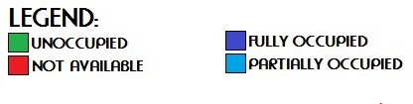

*\*\*Note:*

*1. UNOCCUPIED - the room is available for renting.*

*2. FULLY OCCUPIED - the room is not available for renting.*

*3. PARTIALLY OCCUPIED - the room is partially occupied, it can be rented depending on the number of the vacant slot/s.*

*3. NOT AVAILABLE - the room is not available because it is under maintenance.*

### 4.4.2 Registration

1. Click  .

2. Click  .

3. Right click the name of the person under the *"Tentative List of Resident(s)"*:

3.1 If you want to cancel the reservation, click *Cancel.*

3.2 If you want to register the reservation and continue, click *Register.*

3.2.1 Upon clicking the *Register*, you will now be able to add information about the resident.

3.2.2. To upload a picture, click on the .

3.2.3. To add furniture/s, click .

3.2.3. To add gadget/s or appliance/s, click .

4. After typing the information of the resident:

4.1. Click the  on the *registration form* to save the data on the under the resident's name.

4.2. Click the on the *registration form* to preview the data on the under the resident's name.

4.3. Click  on the *registration form* to cancel the registration form go back to the *main menu*.

#### 4.4.2.1 Add furniture

1. Under the registration, click .

2. Click on the  under the *Room Inventory* table.

3. Upon clicking, select a furniture from the left table (list of available furnitures will be listed here).

4. After selecting a furniture, click  to assign the furniture to the resident.

5. If you want to remove a furniture from the *list of furniture(s) on the right table*, click .

6. Click  to cancel the assigned furniture on the resident and go back to the *inventory form*.

7. Click  to assign the furniture on the resident and go back to the *inventory form*.

7.1. Click the  on the *inventory form* under the *Room Inventory* table to save the confirmed furniture on the resident's name.

7.2. Click the on the *inventory form* under the *Room Inventory* table to preview the confirmed furniture on the resident's name.

7.3. Click  on the *inventory form* under the *Room Inventory* table to clear all the confirmed furniture on the resident's name.

#### 

#### 4.4.2.2 Add Gadget

1. Under the registration, click .

2. To assign number of gadget/s or appliance/s, click the arrow up to add more gadgets, and arrow down to lessen the number of gadgets on the .

3. To input the gadget/s or appliance/s in the *Appliance and Gadget Inventory* table, type on the columns on the table.

4. After typing the gadget/s or appliance/s in the *Appliance and Gadget Inventory* table:

4.1. Click the  on the *inventory form* under the *Appliance and Gadget Inventory* table to save the gadget/s or appliance/s on the resident's name.

4.2. Click the on the *inventory form* under the *Appliance and Gadget Inventory* table to preview the gadget/s or appliance/s on the resident's name.

4.3. Click  on the *inventory form* to cancel the inventory form on the resident's name and go back to the *registration form*.

### 4.4.3 Activation

1. Click  .

2. Click  .

3. The list of residents will appear, right click on the name of a specific resident:

3.1. To activate the use of biometrics of a resident, click *Activate Biometrics.*

3.2. To deactivate the use of biometrics of a resident, click *Deactivate Biometrics.*

3.3. To view profile of a resident, click *View Profile.*

3.4 To change the room of a resident, click *Change Room.*

3.5. If a resident will leave the dorm permanently, click *Leave Dorm.*

4. Click the  to go back to the main menu.

### 4.4.4 Edit Resident Profile

1. Click  .

2. Click  .

3. The list of residents will appear, right click on the name of a specific resident, to view profile of a resident, click *View Profile.*

3.1. To edit the information of a resident, click .

3.2. To change the resident's profile picture, click

#### 4.4.4.1 View Profile

##### 4.4.4.1 Edit Profile

1. Click  .

2. Click  .

3. The list of residents will appear, right click on the name of a specific resident.

4. Click *View Profile.*

5.Click .

6. Change the Information that needs to be change.

7. Click .

##### 4.4.4.2 Edit Furniture and Gadget

1. Click  .

2. Click  .

3. The list of residents will appear, right click on the name of a specific resident.

4. Click *View Profile.*

5. Click the  , located at the upper left.

6. To edit the information of a gadget:

6.1 Select a gadget.

6.2 Click .

6.3 Edit the information.

6.4 Click .

7. To add a gadget:

7.1 Click .

7.2 Input the information of the gadget.

7.3 Click .

8. To assign a furniture to a resident.

8.1 Select a furniture in the *Room Furniture List*

8.2 Click 

9. To remove a furniture assigned to a resident:

9.1 Select a furniture in the *Resident Furniture List*

9.2 Click 

#### 4.4.4.2 Change Room

1. Click  .

2. Click  .

3. The list of residents will appear, right click on the name of a specific resident.

4. Click *Change Room.*

5. Select the new room of the resident by selecting:

5.1 In the drop down 

5.2 By using the 

6. Click .

### 4.4.5 Billing

1. Click  .

2. Click 

3. Search a resident in the search bar.

4. Click  to filter by category.

#### 4.4.5.1 Statement of Account

1. Click  .

2. Click 

3. Search a resident in the search bar.

4. Click  to filter by category.

5.If you want to check the statement of account of a resident just right click on the resident's name and click .

6. After clicking on the statement of accounts you can edit the monthly rate(room rate per 30 days), the shuttle rate which is monthly or the number of rides a

resident accumulated within the day. If it is monthly just click on the radio button  for monthly, but if the resident accumulated the number of rides

just click on the radio button  rides and click  and by double clicking on the  column you can already input

the number of rides of a resident and it will already count, also choose the gadget of the resident that he/she will pay, you can also put your remarks.

*Note: in the Date/s Availed, double click the space provided on the right side of the date, then type the number of rides the resident accommodated.*

7. Click .

#### 4.4.5.2 Payment of Remittance

1. Click  .

2. Click 

3. Search a resident in the search bar.

4. Click  to filter by category.

5. If a resident will pay for his/her monthly billing just right click on the resident's name and click .

6. If the resident will pay all (Room rate, Shuttle service, additional appliance/ gadget and additional 10%(if applicable)) click on the check boxes 

of the room rate, Shuttle service, additional appliance/ gadget and additional 10% and the total amount will be automatically be shown at the total amount field.

7. A resident can also pay the room rate only, the shuttle rate only, the appliance only and the additional 10% only just click on the check boxes  for those fields.

8. The total amount, amount paid, and balance are shown, under the amount paid you can enter the amount that the resident will be paying.

9. You can also enter your remarks.

10. Click .

### 4.4.6 Leave

1. Click  .

2. Click  .

3. The list of residents will appear, right click on the name of a specific resident.

4. Select *Leave Dorm.*

## 4.5 Transient

1. Click .

2. Click .

3. Click .

4. Fill up the necessary information.

5. If the transient is related to a resident and do not want to stay at the same room with the resident:

5.1 Click the and select the name of the resident.

5.2 Click  to select the relationship of the transient to the resident.

5.3 Click the  and select the room.

5.4 Click the  to choose the date of arrival and departure.

5.5 Click  to add additional guest, then fill up the names in the text field provided.

5.6 Input the monetary charge per person of the transient.

5.7 If extra bedding is needed, click  beside the *No. of Extra Bed/s,*then input the bed charge.

5.8 Input the *Total Amount* and the *Amount Paid*.

6. If the transient is related to a resident and would like to stay at the same room with the resident:

6.1 Click and select the residents name

6.2 Click  to select the relationship of the transient to the resident.

6.3 Click .

6.4 Click the  to choose the date of arrival and departure.

6.5 Click  to add additional guest, then fill up the names in the text field provided.

6.6 Input the monetary charge per person of the transient.

6.7 If extra bedding is needed, click  beside the *No. of Extra Bed/s,*then input the bed charge.

6.8 Input the *Total Amount* and the *Amount Paid*.

7. If the transient is not related to a resident:

7.1 Click the  and select the room.

7.2 Click the  to choose the date of arrival and departure.

7.3 Click  to add additional guest, then fill up the names in the text field provided.

7.4 Input the monetary charge per person of the transient.

7.5 If extra bedding is needed, click  beside the *No. of Extra Bed/s,*then input the bed charge.

7.6 Input the *Total Amount* and the *Amount Paid*.

## 4.6 Back-up and Recovery

1. Click the 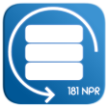 to open the Backup and Recovery.

**Backup Database:**

1. A summary of the database tables is shown as a reference in the backing up of the database.

2. Click **,** to backup the current database.

**Down System Back-up:**

1. Billing:

1.1 Click 

1.2 Select the resident to whom his/her statement of account or payment remittance must be added.

1.3 Right Click the name of the resident to select form *Statement of Account and Payment Remittance.*

1.4 Fill up necessary information.

1.5 Click  or  .

2. Reservation:

2.1 Click  .

2.2 Fill up the necessary information of the reserver.

2.3 Click  .

3. Registration:

3.1 Click  .

3.2 Fill up the necessary information.

3.3 Click  .

4. Transient:

4.1 Click  .

4.2 Fill up the necessary information.

4.3 Click  .

5. Time in/out:

5.1 Click  .

5.2 Click  to upload an Excel file that contains the logs of the resident.

5.3 Click  to compare the value of the Excel file to the database.

5.4 The affected row/s will be shown in the Logs.

*NOTE: Fixed the rows in the Excel file that were affected, then re-upload the Excel file. A successful message will be shown if there are no more rows that were invalid.*

6. Visitor Login:

6.1 Click  .

6.2 Fill up the necessary information.

6.3 Click  .

**Recover Database:**

1. Click  to upload a new database.

2. Click  .

## 4.7 Report Generation

1. Click .

2. Click .

3. Click and select on what result to be shown.

*\*Note: you can select, Number of Reservation, Number of Registration, Number of Late Residents and Number of Payers.*

4. Click to select on what year.

5. Click  to select time period.

6. Click 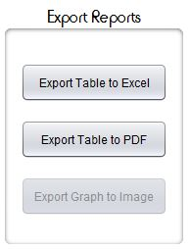 to export the result to Excel, PDF and Image.

### 4.7.1 Archives

1. Click .

2. Click 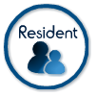 to show the list of the Personal Information, Contact Information, Address and Status of the resident.

2.1 Click  to export the information to PDF.

2.2 Click  to export the information to Excel.

3. Click  to show the list of the Personal Information, Check-In Details, and Guest of each transient.

3.1 Click  to export the information to PDF.

3.2 Click  to export the information to Excel.

4. Click  to show the list of the visitors.

4.1 Click  to export the information to PDF.

4.2 Click  to export the information to Excel.

5. Click 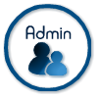 to show the list of Administrator's information.

5.1 Click  to export the information to PDF.

5.2 Click  to export the information to Excel.

6. Click  to show the list Resident. It will show the Personal Information, Contact Information, Father Information, Mother Information, Guardian Information and Guardian Address.

6.1 Click  to export the information to PDF.

6.2 Click  to export the information to Excel.

7. Click  to show the list of all the reserver in 181 North Place Residences.

7.1 Click  to export the information to PDF.

7.2 Click  to export the information to Excel.

8. Click  to show the logs of the resident.

8.1 Click  to export the information to PDF.

8.2 Click  to export the information to Excel.

9. Click  to show the Account Summary, the Transient and Resident's Date Paid, Name, Received by and Amount Paid.

9.1 Click  to export the information to PDF.

9.2 Click  to export the information to Excel.

10. Click 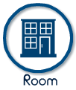 to show the room details. It shows the Dorm Number, Room Id, Room Number, Room Type and Room Status.

10.1 Click  to export the information to PDF.

10.2 Click  to export the information to Excel.

11. Click  to show the Furnitures of the dormitory. It shows the Item Name, Control Number, Color, Brand and Purchase Date.

11.1 Click  to export the information to PDF.

11.2 Click  to export the information to Excel.

12. Click  to show the list of Resident who left the dormitory. It shows the Personal Information, Contact Information, Address and Status of the resident.

12.1 Click  to export the information to PDF.

12.2 Click  to export the information to Excel.